DYMO Events

DYMO coordinates a number of events throughout the year. Check them out below:

Annual Diocesan Summer Camp
Our Diocesan Summer Camp brings together young people (13 – 17 years old) over 4 days to experience the Catholic faith in a powerful, vibrant and fun way. Camp includes a range of activities such as games, music, team building, talks, prayer and liturgy, reflections, workshops and group discussions. Each year a new theme for the Camp is chosen so no camp is ever the same. Established in 2012, our Diocesan Summer Camp takes place in early to mid-January every year.
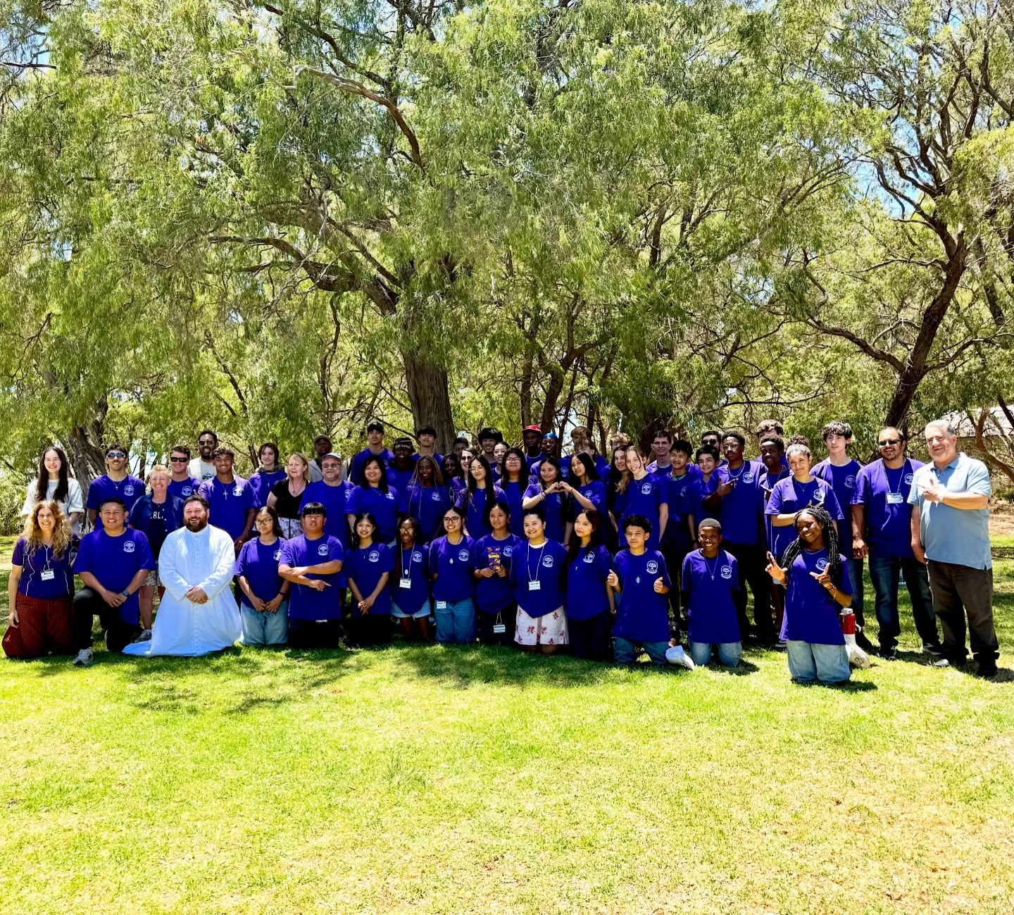

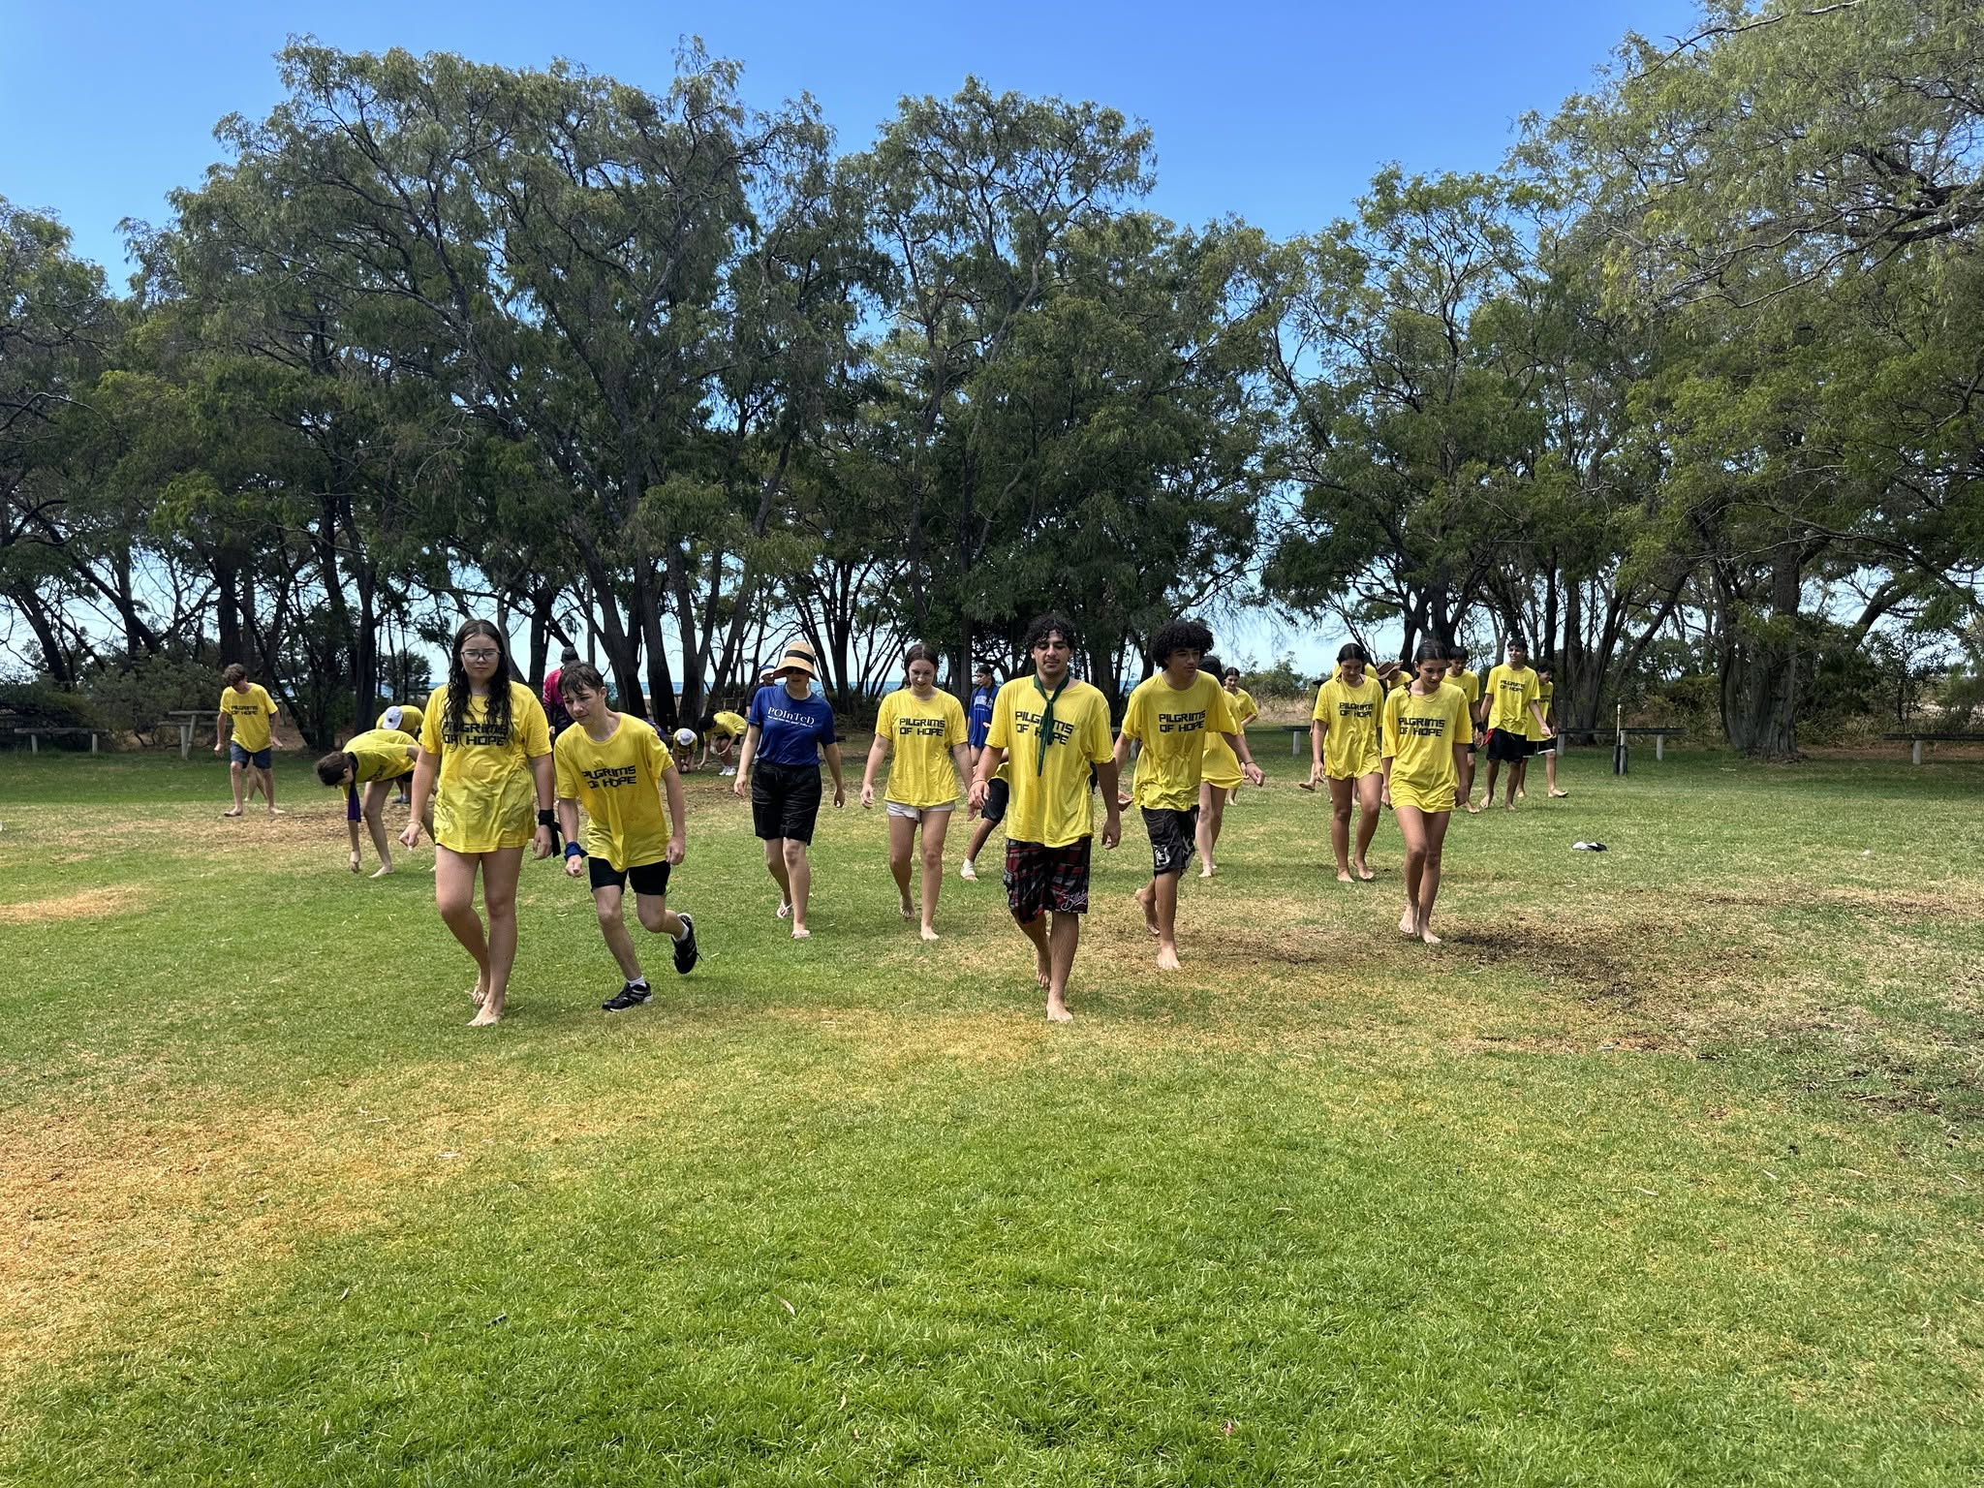

Leadership Training and Formation
DYMO provides leadership training, formation and mentorship to youth ministry leaders. Training and formation days are offered in the lead up to large Diocesan events or at the request of parishes. Session blend a range of theological, pastoral, and technical topics designed to ensure well rounded and capable youth ministry leaders.
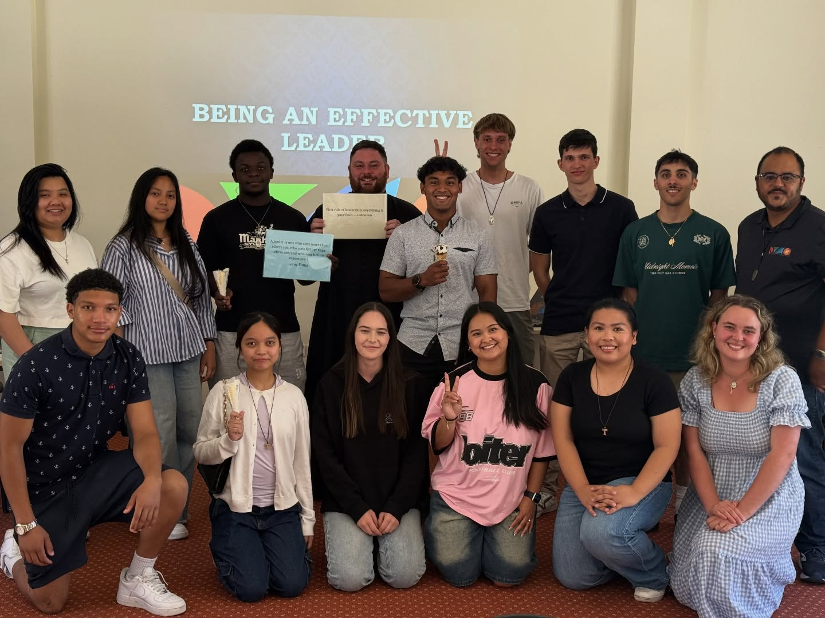

Australian Catholic Youth Festival
The Australian Catholic Youth Festival (ACYF) is a national gathering of Catholic young people established by the Australian Catholic Bishops Conference (ACBC). It exists to provide young people with opportunities to deepen their relationship with Jesus, be empowered to be disciples in the world today and encounter and celebrate the vitality of the Church in Australia. The Diocesan Youth Ministry Office (DYMO) has coordinated an Official Diocesan Pilgrimage for the Australian Catholic Youth Festival each year it has occurred. The Official Diocesan Pilgrimage includes range of extras such as flights, social activities, sightseeing, some meals, accommodation, airport transfers, activities, spiritual programs, discussion groups, mentoring, pastoral care, games, music and much, much more.
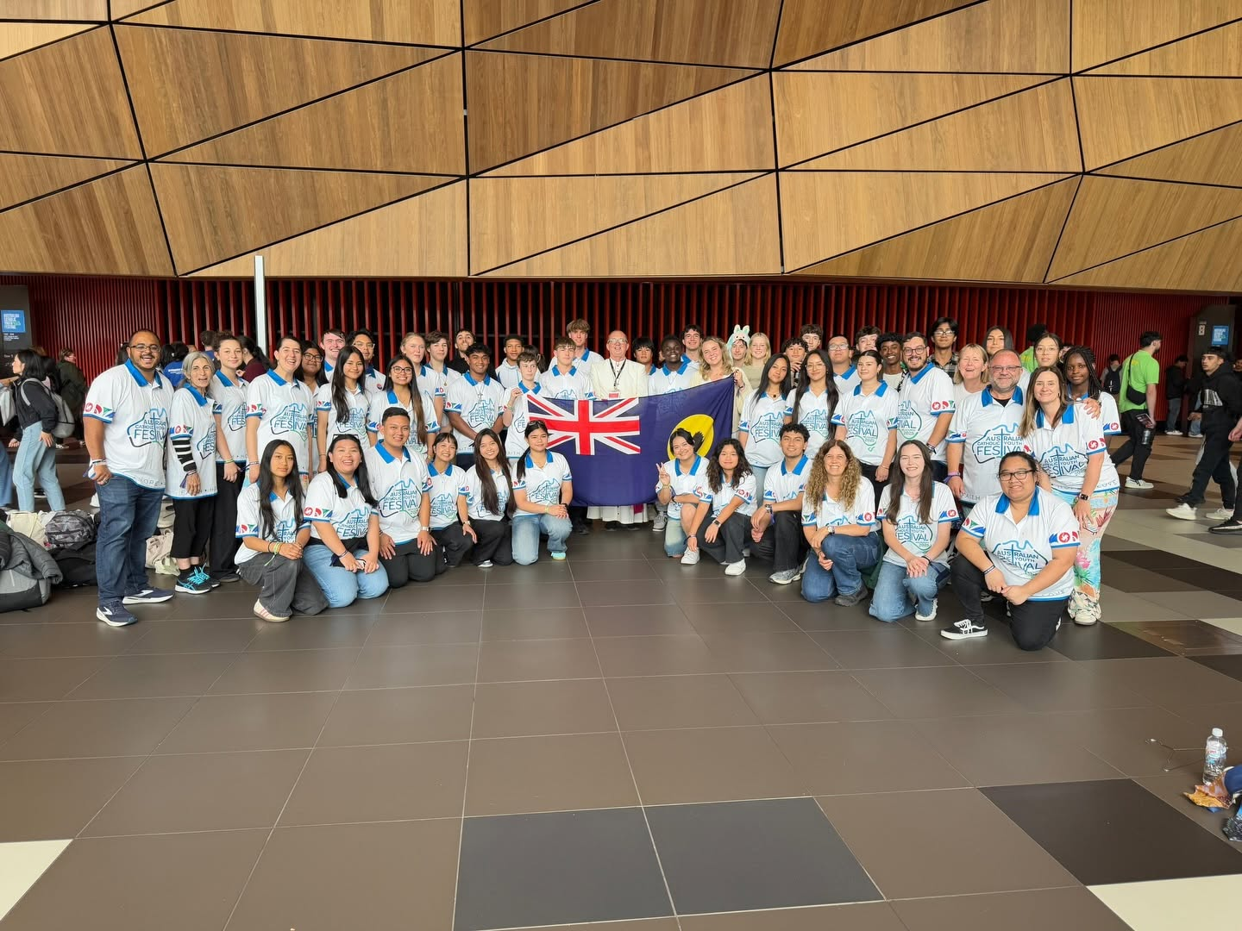

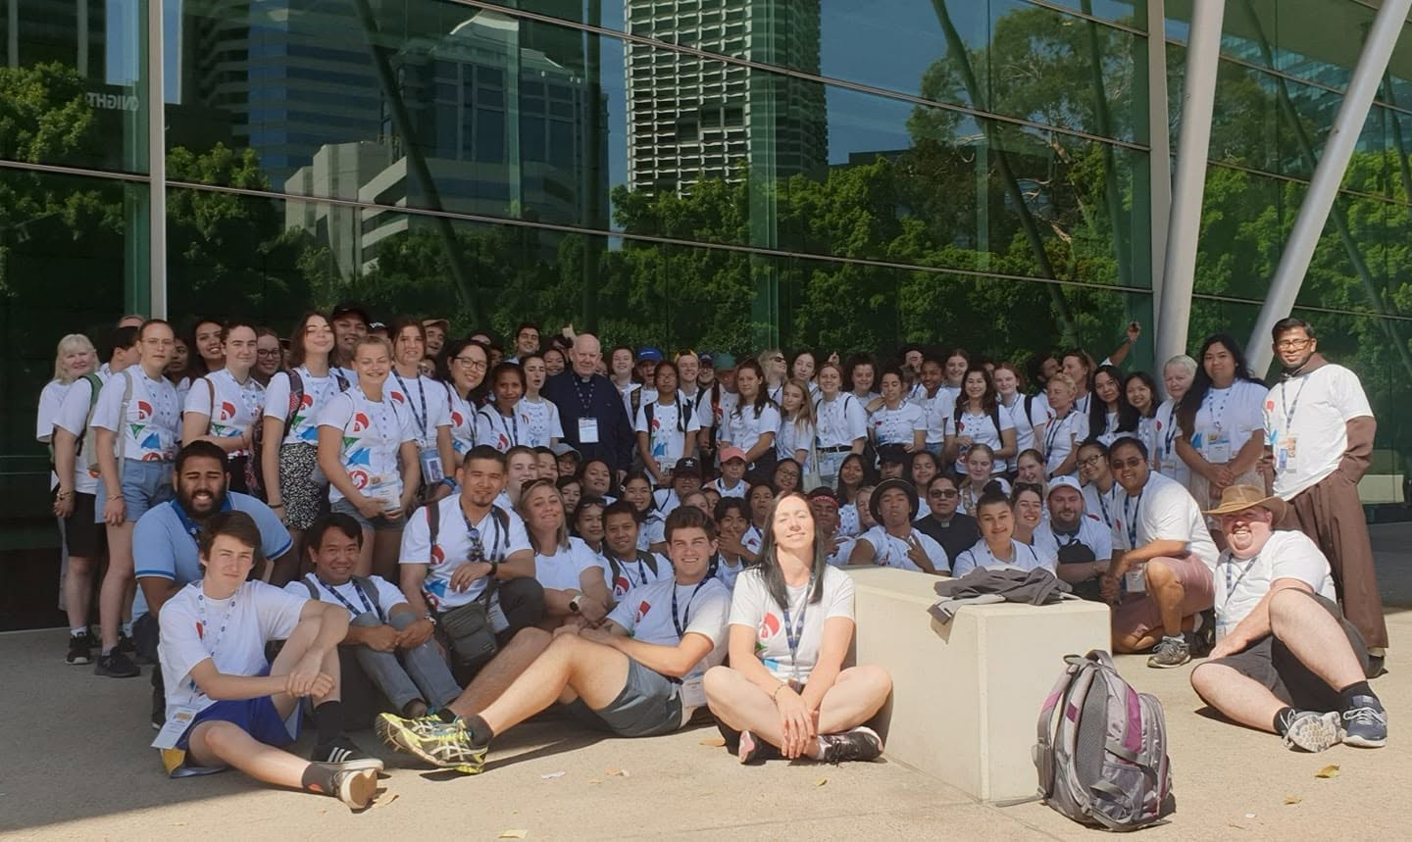

World Youth Day
World Youth Day (WYD) is a global celebration of young people and the Catholic faith. WYD was started by Pope Saint John Paul II as a way to inspire the youth and encourage them in living the teachings of Christ. The first official WYD was held in Rome in 1986 with surprising success that has only grown through the years. Since then, WYD has been celebrated either on Palm Sunday in every Diocese, or every 2-3 years as an international celebration hosted in a global city. In 2019 WYD local celebrations were moved to the feast of Christ the King.
International WYD week begins with an opening Mass. During the week youth gather to listen to each other and bishops, to learn more about the teachings of the faith through catechesis and festivals. Mid-week the Pope arrives in the city is welcomed by the youth. The Pope also leads a Stations of the Cross, a Vigil and a concluding Mass, which often attracts millions of pilgrims.
DYMO coordinates a Diocesan Pilgrimage to WYD, sometimes in partnership with other dioceses and an official tour provider. The Diocesan Pilgrimage includes range of extras such as flights, meals, accommodation, airport transfers, activities, spiritual programs, discussion groups, mentoring, pastoral care, prayer and liturgy, missionary activities, and much, much more.

