About the Diocesan Youth Ministry Office (DYMO)

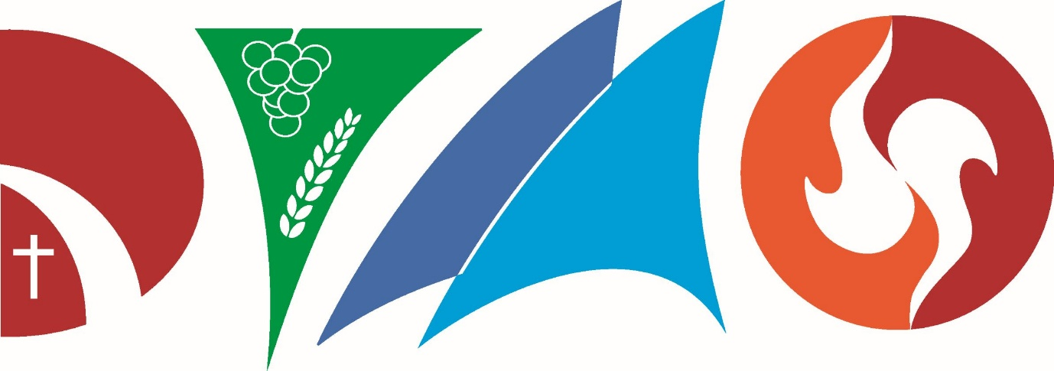

Our Vision
Loving young people and forming Christ within to transform the world.

Our Mission
To demonstrate and grow excellent ministry to young people by providing spiritual, creative, leadership and administrative support to the Church.
To empower all young people to live as disciples of Christ.

Our Logo
Our logo was chosen from a range of entries into our logo competition in 2017.
The logo is a stylised text which represents the letters DYMO representing the acronym for the Diocesan Youth Ministry Office.
The letter D Incorporates the Bishop’s mitre in the lower left corner, the road way is symbolic of country towns of the Diocese and of journeying.
The letter Y form is taken from a chalice with the symbols of grapes and wheat representing farming communities and the Eucharist.
The letter “M” is formed by two sails representing the coastal towns of the Diocese.
The letter “O” has fire indicating the role of the Holy Spirit in forming the young people of the Diocese.

Our Structure

DYMO is the official Youth Office of the Diocese of Bunbury. The office is responsible to the Roman Catholic Bishop of Bunbury.
The Diocesan Youth Council (DYC) was established by the Bishop of Bunbury for the purpose of advising him on Diocesan Youth matters. The DYC is governed by the Statutes and Role of the DYC documents. Appointments to the Council are made by the Bishop of Bunbury with all parishes given the opportunity to nominate members.
DYMO includes a diverse range of committed volunteers who generously give their time to aid the work and ministry of the office. Young people are also a key part of our structure who attend and support events and consult on activities and initiatives.
The accountability and responsibility structure is presented in the following diagram:

Christ

Our Core Beliefs
The Diocesan Youth Ministry Office’s guiding beliefs in its ministry are:
- We are representatives of Christ and His Church. We must uphold the beliefs, practices and teachings of the Roman Catholic Church.
- Christ is already present and working in the lives of young people.
- All young people are called to have a deeper relationship with Christ.
- Youth Ministry is grounded in the desire for what is ultimately good, true and beautiful for each and every young person.
- God is loving, merciful and has a good plan for all young people.
- DYMO is established to listen to the voice of Christ in order to discern the needs of Youth Ministry in the Diocese and minster to these needs effectively.
- Young people should be affirmed, supported, connected and encouraged in the Church.
- Youth Ministry should affect the whole life of the Church and of Parishes as it is a whole community initiative.
- Young people have a rightful place in the Church of today and should be active members of the Church.
- Youth Ministry should respond to the needs of young people.

Our Values

History and Appointment

The current Diocesan Youth Ministry Office (DYMO) was created in January 2015 by the Most Reverend +Gerard J Holohan, Bishop Emeritus of Bunbury.
In 2022 the Youth Coordinator role was upgraded to a Youth Director role by Bishop Holohan.
The Youth Leadership Team was (YLT) was a group of both new and experienced leaders and volunteers who met regularly for formation, training, fellowship and to plan Diocesan Youth Ministry events and initiatives. It was formed in 2019 and disbanded at the end of 2020.
In 2017 the Diocesan Youth Council was established as the key consultative and strategic body in Youth Ministry for the Diocese. DYC members are appointed for a two year term by the Bishop of Bunbury which can be renewed each year. The Council was dissolved in December 2025.
The Youth Office in 2015 was comprised of a Diocesan Youth Ministry Coordinator (DYMC), Mr. Aaron Faure and Youth Chaplain, Fr. Christian Saminal OSJ and was called the Diocese of Bunbury Youth Ministry Office (BYMO).
Prior to this Fr. Wayne Bendotti had held the role of Youth Coordinator from 2011 to 2014. Prior to this the role was held by Sue Barton from 2004 to 2009.
Youth Ministry has in the Diocese of Bunbury has grown over many years. Activities include an annual Summer Camp since 2012, involvement in the Australian Catholic Youth Festival, Australian Catholic Youth Ministry Conventions, Veritas Western Australia Youth Festival, World Youth Days as well as many local and parish based initiatives and activities.

Our Future
Our goal for the future is to have a vibrant, healthy and active Catholic Youth community developing a relationship with Christ and the Church throughout the Diocese of Bunbury. Our vision is to have Youth Ministry initiatives in every parish as well as annual Diocesan Youth Ministry events. This will be supported by a network of Youth Ministers from every parish that communicate and collaborate with each other and support each other for effective ministry. In every parish there would also be well formed and well trained Youth Leaders who love the faith and inspire other young people.

Goals and Strategies
DYMO has developed the following goals to effectively achieve its vision and mission. These goals are stepping stones to our vision for the future and a guide for actions of the present. Listed below are the strategies implemented to achieve each goal. Goals and listed in order of important and priority for DYMO.

Goals
- Form, support and develop young people to integrate faith and life and become missionary disciples.
- Create, grow and support Catholic Youth community and culture.
- Develop, form and mentor youth ministry leaders.
- Create and encourage collaboration between key stakeholders (such as youth leaders, parents, teachers and others) in youth ministry.
- Create and encourage a collaborative relationship for youth ministry between Catholic Colleges, parishes and DYMO.
- Grow, develop and support youth ministry initiatives in parishes.
- Coordinate Diocesan involvement in Local, State, National and International events and initiatives.
- Encourage and support Clergy in youth ministry.
- Create, compile and share resources for youth ministry.
- Create and develop structures and processes for youth ministry for the Diocese and parishes.

